Fetch-Decode-Execute Cycle
The fetch-decode-execute cycle, also known as the instruction cycle, is the fundamental process that the central processing unit (CPU) uses to process instructions from a program. It's a continuous, repetitive loop that the CPU follows from the moment a computer boots up until it's shut down.
The Three Stages
Fetch
The first stage is fetch. The CPU retrieves the next instruction from the main memory. It uses a special register called the program counter (PC), which holds the memory address of the next instruction to be executed. The PC's value is sent to the Memory Address Register (MAR), which then sends a signal to the memory over the address bus to retrieve the instruction at that location. The instruction is then sent back to the CPU via the data bus and stored in the Memory Data Register (MDR), and then into the Instruction Register (IR). After fetching the instruction, the PC is incremented to point to the next instruction in the sequence.
Decode
Once the instruction is in the IR, the CPU moves to the decode stage. Here, the Control Unit (CU) interprets the instruction's binary code. Every instruction is composed of two parts: an opcode (operation code), which specifies the action to be performed (e.g., addition, data transfer, a jump), and the operands, which are the data or memory addresses needed for the operation. The CU translates this instruction into a set of control signals that prepare the other CPU components, like the Arithmetic Logic Unit (ALU) and registers, for the next stage.
Execute
The final stage is execute. The CPU carries out the operation specified by the instruction using the components prepared during the decode phase. This might involve the ALU performing an arithmetic or logical calculation, the CPU reading from or writing to memory, or a jump instruction altering the value of the program counter to a new memory address. The result of the operation is then stored in a register or a memory location, as required by the instruction. After execution is complete, the cycle repeats, starting with the fetch of the next instruction.
Example:
Use the fetch-decode-execute cycle to add two numbers, 5 and 10, and then display the result.

Solution:
For this, we'll imagine a simple program with a few instructions.
1. Fetch
The program counter (PC) holds the memory address of the first instruction, which is to load the number 5 into a register. The CPU fetches this instruction from memory. For simplicity, let's say the instruction is LOAD R1, #5, where R1 is a register and #5 is the value. The instruction is brought into the Instruction Register (IR). After fetching, the PC is incremented to point to the next instruction.
2. Decode
The control unit decodes the instruction in the IR. It recognizes the LOAD opcode and identifies two operands: the destination register R1 and the immediate value 5. The control unit then generates signals to prepare the necessary components to execute this instruction.
3. Execute
The execution stage begins. The control unit sends a signal to the data path to load the value 5 directly into register R1. The CPU now has one of the numbers it needs for the addition.
The cycle repeats for the second number.

4. Fetch
The PC now points to the next instruction: LOAD R2, #10. The CPU fetches this instruction and places it in the IR. The PC is incremented again.
5. Decode
The control unit decodes the LOAD R2, #10 instruction. It identifies the LOAD opcode, the destination register R2, and the value 10.
6. Execute
The control unit directs the CPU to load the value 10 into register R2. Now both numbers, 5 and 10, are in their respective registers (R1 and R2).
The cycle repeats for the addition itself.

7. Fetch
The PC points to the ADD R3, R1, R2 instruction. This instruction tells the CPU to add the values in R1 and R2 and store the result in a third register, R3. The CPU fetches this instruction into the IR and increments the PC.
8. Decode
The control unit decodes the ADD instruction. It identifies the operation (ADD), the destination register (R3), and the source operands (R1 and R2). It sets up the Arithmetic Logic Unit (ALU) for an addition operation and directs it to receive the contents of R1 and R2.
9. Execute
The ALU performs the addition. It takes the values from R1 (5) and R2 (10), performs the calculation, and produces the result, 15. The control unit then directs the ALU's output (15) to be stored in register R3.
Finally, the cycle repeats to display the result.
10. Fetch, Decode, and Execute for Display
The CPU fetches an instruction like DISPLAY R3. The control unit decodes this, recognizing that it needs to send the value in register R3 to the output device (like a monitor). In the execute stage, the CPU sends the value 15 from R3 to the appropriate output hardware, and the number appears on the screen.

Impact of Buses and Registers on Performance and Efficiency
A computer's speed and efficiency heavily depend on its buses and CPU registers.
Buses: The Data Highways
Think of buses as the highways inside your computer, transferring data between components like the CPU, memory, and peripherals. Two key aspects of buses matter:
- Data Bus Width: This is like the number of lanes on the highway. A wider bus (e.g., 64-bit) can carry more data at once compared to a narrower one (e.g., 32-bit), assuming they operate at the same speed. This means more data is transferred in each cycle, speeding up tasks like fetching data from memory.
- Bus Speed (Clock Rate): This is the speed limit on the highway. A bus speed describes how fast data can be transferred over the bus, which is directly determined by its clock rate. A higher clock rate means the bus can perform more data transfer operations per second.
- Address Bus Width: This determines how much memory the CPU can directly access. If the address bus is too narrow, the system can't use all available RAM, limiting the size and complexity of programs that can run efficiently.

Bottlenecks: If the bus isn't wide or fast enough for the components connected to it (like a fast CPU), it becomes a bottleneck. The CPU might have to wait for data, slowing down the entire system.

CPU Registers: The CPU's Workbench
Registers are small, ultra-fast storage locations directly within the CPU.
- Register Size (Word Size): This dictates how much data the CPU can work on in a single operation. Larger registers (e.g., 64-bit) allow the CPU to handle bigger numbers and more complex calculations faster than CPUs with smaller registers (e.g., 32-bit would need multiple steps for the same 64-bit calculation).
- Number of Registers: More registers mean the CPU can keep more of the data it's actively using close at hand. This reduces the need to constantly fetch data from the slower main memory, leading to faster program execution.
Bottlenecks: If there aren't enough registers, the CPU has to frequently save data to main memory and retrieve it later (called "spilling"). This is much slower than accessing data already in a register and can significantly slow down programs.

Overcoming Limitations: Optimization Techniques
Modern computers use several strategies to work around these potential limitations:
- Caching: Small, fast memory units (caches) are placed closer to the CPU than the main memory. Frequently used data is stored here, reducing the need to use the main bus and access slower memory.
- Register Renaming: Advanced CPUs can effectively increase the number of available registers by cleverly managing a larger internal set of physical registers. This helps reduce data conflicts and allows more instructions to run in parallel.
- Compiler Optimizations: The software that translates programming languages into machine code (the compiler) can arrange instructions and allocate variables to registers efficiently, minimizing memory access.
- Direct Memory Access (DMA): This allows certain hardware components (like disk drives or network cards) to transfer data directly to and from main memory without involving the CPU. This frees up the CPU and the system bus for other tasks, improving overall efficiency.
In short, wider and faster buses, along with larger and more numerous CPU registers, are crucial for high performance. When these are limited, they create bottlenecks, but various optimization techniques help mitigate these issues.
The Roles of Buses and Registers
Buses and Registers are foundational components in computer architecture, each playing an indispensable role in enabling the operation of a computer system. Buses provide the essential communication infrastructure that allows for the transfer of data between the various components, with their width and speed being critical factors in determining the overall performance and responsiveness of the system. Registers, located within the CPU, offer high-speed temporary storage for data and instructions that are being actively processed, and their size and number significantly impact the CPU's efficiency and processing capabilities. The coordinated interaction between buses and registers is fundamental to the instruction execution cycle, the very heart of how a computer processes information.
The technologies surrounding buses and registers continue to evolve rapidly to meet the ever-increasing demands of modern computing. Bus technologies are constantly being refined to provide higher bandwidth for the growing data transfer needs of current applications and peripherals. Similarly, CPU architectures are continuously being enhanced with larger register files, wider registers capable of handling more data in parallel (such as 128-bit and 256-bit vector registers), and more sophisticated
register management techniques aimed at maximizing performance. The ongoing challenge in computer architecture lies in finding the optimal balance between bus design, register architecture, and other factors such as cache hierarchy to create systems that are both powerful and efficient.

SOFTWARE
Software is a set of instructions, data or programs used to operate computers and execute specific tasks. It is the opposite of hardware, which describes the physical aspects of a computer. Software is a generic term used to refer to applications, scripts and programs that run on a device. It can be thought of as the variable part of a computer, while hardware is the invariable part.
The two main categories of software are application software and system software. An application is software that fulfils a specific need or performs tasks. System software is designed to run a computer's hardware and provides a platform for applications to run on top of.
Other types of software include programming software, which provides the programming tools software developers need; middleware, which sits between system software and applications; and driver software, which operates computer devices and peripherals.
Early software was written for specific computers and sold with the hardware it ran on. In the 1980s, software began to be sold on floppy disks, and later on CDs and DVDs. Today, most software is purchased and directly downloaded over the internet. Software can be found on vendor websites or application service provider websites.
Examples and types of software
Among the various categories of software, the most common types include the following:
- Application software. The most common type of software, application software is a computer software package that performs a specific function for a user, or in some cases, for another application. An application can be self-contained, or it can be a group of programs that run the application for the user. Examples of modern applications include office suites, graphics software, databases and database management programs, web browsers, word processors, software development tools, image editors and communication platforms.
- System software. These software programs are designed to run a computer's application programs and hardware. System software coordinates the activities and functions of the hardware and software. In addition, it controls the operations of the computer hardware and provides an environment or platform for all the other types of software to work in. The OS is the best example of system software; it manages all the other computer programs. Other examples of system software include the firmware, computer language translators and system utilities.
- Driver software. Also known as device drivers, this software is often considered a type of system software. Device drivers control the devices and peripherals connected to a computer, enabling them to perform their specific tasks. Every device that is connected to a computer needs at least one device driver to function. Examples include software that comes with any nonstandard hardware, including special game controllers, as well as the software that enables standard hardware, such as USB storage devices, keyboards, headphones and printers.
- Middleware. The term middleware describes software that mediates between application and system software or between two different kinds of application software. For example, middleware enables Microsoft Windows to talk to Excel and Word. It is also used to send a remote work request from an application in a computer that has one kind of OS, to an application in a computer with a different OS. It also enables newer applications to work with legacy ones.
- Programming software. Computer programmers use programming software to write code. Programming software and programming tools enable developers to develop, write, test and debug other software programs. Examples of programming software include assemblers, compilers, debuggers and interpreters.

How does software work?
All software provides the directions and data computers need to work and meet users' needs. However, the two different types -- application software and system software -- work in distinctly different ways.
Application software
Application software consists of many programs that perform specific functions for end users, such as writing reports and navigating websites. Applications can also perform tasks for other applications. Applications on a computer cannot run on their own; they require a computer's OS, along with other supporting system software programs, to work. They consist of:
- Desktop applications are installed on a user's computer and use the computer memory to carry out tasks. They take up space on the computer's hard drive and do not need an internet connection to work. However, desktop applications must adhere to the requirements of the hardware devices they run on.
- Web applications, on the other hand, only require internet access to work; they do not rely on the hardware and system software to run. Consequently, users can launch web
applications from devices that have a web browser. Since the components responsible for the application functionality are on the server, users can launch the app from Windows, Mac, Linux or any other OS.
Web Application vs Desktop Application
Web Application | Desktop Application
Runs inside a web browser | It can only be accessed from the device it is installed on
Hosted on web/application servers | Hosted/run directly from the user’s device
Accessible from any internet-connected device | Can only be accessed from the device it is installed on
Requires no installation, just a web browser | Requires installation and takes up space on the user’s device
The web server handles updates | Updates need to be installed by the user on their device
Example applications include Gmail, Facebook, Twitter etc | Example applications include MS Word, Photoshop, Visual Studio etc

System software
System software sits between the computer hardware and the application software. Users do not interact directly with system software as it runs in the background, handling the basic functions of the computer. This software coordinates a system's hardware and software so users can run high-level application software to perform specific actions. System software executes when a computer system boots up and continues running as long as the system is on.
System Software Vs. Application Software
System Software | Application Software
General-purpose software that manages basic system resources and processes. | Software that performs specific tasks to meet user needs.
Written in low level assembly language or machine code. | Written in higher level languages such as Python and JavaScript.
Must meet specific hardware needs; Interacts closely with hardware. | Does not take hardware into account and doesn’t interact directly with hardware.
Installed at the same time as the OS, usually by the manufacturer. | User or admin install software when needed.
Runs anytime the computer is on. | User triggers and stops the program.
Works in the background and users don't usually access it. | Runs in the foreground and users work directly with the software to perform specific tasks.
Runs independently. | Needs systems software to run.
Is necessary for the system to function. | Isn't needed for the system to function.
GENERATIONS OF A COMPUTER
Generation in computer terminology is a change in technology a computer is/was being used. Initially, the generation term was used to distinguish between varying hardware technologies. But nowadays, generation includes both hardware and software, which together make up an entire computer system.
There are totally five computer generations known till date. Each generation has been discussed in detail along with their time period and characteristics. Here approximate dates against each generation have been mentioned which are normally accepted.
Following are the main five generations of computers:
First generation:
The period of first generation was 1946-1959. The computers of first generation used vacuum tubes as the basic components for memory and circuitry for CPU (Central Processing Unit). These tubes, like electric bulbs, produced a lot of heat and were prone to frequent fusing of the installations, therefore, were very expensive and could be afforded only by very large organizations. In this generation mainly batch processing operating system were used. Punched cards, paper tape, and magnetic tape were used as input and output devices. The computers in this generation used machine code as programming language.
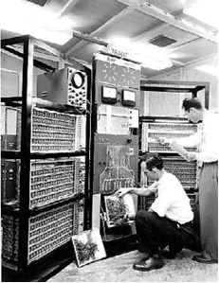
The main features of first generation are:
- Vacuum tube technology
- Unreliable
- Supported machine language only
- Very costly
- Generated lot of heat
- Slow input and output devices
- Huge size
- Need of A.C.
- Non-portable
- Consumed lot of electricity
Some computers of this generation were:
- ENIAC
- EDVAC
- UNIVAC
- IBM-701
- IBM-650

Second generation:
The period of second generation was 1959-1965. In this generation transistors were used that were cheaper, consumed less power, more compact in size, more reliable and faster than the first-generation machines made of vacuum tubes. In this generation, magnetic cores were used as primary memory and magnetic tape and magnetic disks as secondary storage devices. In this generation assembly language and high-level programming languages like FORTRAN, COBOL were used. The computers used batch processing and multiprogramming operating system.
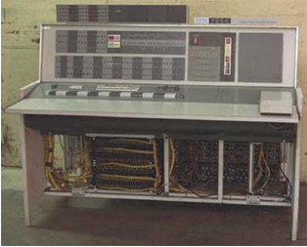
The main features of second generation are:
- Use of transistors
- Reliable in comparison to first generation computers
- Smaller size as compared to first generation computers.
- Generated less heat as compared to first generation computers.
- Consumed less electricity as compared to first generation computers.
- Faster than first generation computers.
- Still very costly.
- A.C. needed.
- Supported machine and assembly languages.
Some computers of this generation were:
- IBM 1620
- IBM 7094
- CDC 1604
- CDC 3600
- UNIVAC 1108

Third generation:
The period of third generation was 1965-1971. The computers of third generation used integrated circuits (IC's) in place of transistors. A single IC has many transistors, resistors, and capacitors along with the associated circuitry. The IC was invented by Jack Kilby. This development made computers smaller in size, reliable and efficient. In this generation remote processing, time-sharing, multi-programming operating system were used. High-level languages (FORTRAN-II TO IV, COBOL, PASCAL PL/1, BASIC, ALGOL-68 etc.) were used during this generation.
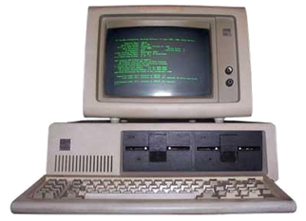

The main features of third generation are:
- IC used
- More reliable in comparison to previous two generations
- Smaller size
- Generated less heat
- Faster
- Lesser maintenance
- Still costly
- A.C needed
- Consumed lesser electricity
- Supported high-level language
Some computers of this generation were:
- IBM-360 series
- Honeywell-6000 series
- PDP Personal Data Processor)
- IBM-370/168
- TDC-316
Fourth generation:
The period of fourth generation was 1971-1980. The computers of fourth generation used Very Large Scale Integrated (VLSI) circuits. VLSI circuits having about 5000 transistors and other circuit elements and their associated circuits on a single chip made it possible to have microcomputers of fourth generation. Fourth generation computers became more powerful, compact, reliable, and affordable. As a result, it gave rise to personal computer (PC) revolution. In this generation time sharing, real time, networks, distributed operating system were used. All the high-level languages like C, C++, DBASE etc., were used in this generation.
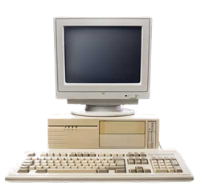
The main features of fourth generation are:
- VLSI technology used
- Very cheap
- Portable and reliable
- Use of PC's
- Very small size
- Pipeline processing
- No A.C. needed
- Concept of internet was introduced
- Great developments in the fields of networks
- Computers became easily available
Some computers of this generation were:
- DEC 10
- STAR 1000
- PDP 11
- CRAY-1(Super Computer)
- CRAY-X-MP(Super Computer)

Fifth generation:
The period of fifth generation is 1980-till date. In the fifth generation, the VLSI technology became ULSI (Ultra Large-Scale Integration) technology, resulting in the production of microprocessor chips having ten million electronic components. This generation is based on parallel processing hardware and AI (Artificial Intelligence) software. AI is an emerging branch in computer science, which interprets means and method of making computers think like human beings. All the high-level languages like C and C++, Java, .Python, etc, are used in this generation.
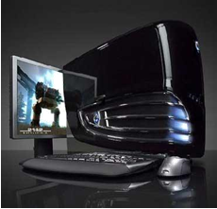
AI includes:
- Robotics
- Neural Networks
- Game Playing
- Development of expert systems to make decisions in real life situations.
- Natural language understanding and generation.
The main features of fifth generation are:
- ULSI technology
- Development of true artificial intelligence
- Development of Natural language processing
- Advancement in Parallel Processing
- Advancement in Superconductor technology
- More user-friendly interfaces with multimedia features
- Availability of very powerful and compact computers at cheaper rates
Some computer types of this generation are:
- Desktop
- Laptop
- Notebook
- Ultrabook
- Chromebook

Examples of Computer Architecture
Two notable examples of computer architecture have paved the way for recent advancements in computing. These are ‘Von Neumann architecture’ and ‘Harvard architecture.
Here’s a description of what these two examples of computer architecture are all about.
Von-Neumann architecture:
Von-Neumann computer architecture design was proposed in 1945. It was later known as Von-Neumann architecture.
Historically there have been 2 types of Computers:
- Fixed Program Computers – Their function is very specific, and they couldn’t be reprogrammed, e.g. Calculators.
- Stored Program Computers – These can be programmed to carry out many different tasks, applications are stored on them, hence the name.
Modern computers are based on a stored-program concept introduced by John Von Neumann. In this stored-program concept, programs and data are stored in a separate storage unit called memories and are treated the same. This novel idea meant that a computer built with this architecture would be much easier to reprogram.
The basic structure is like this,
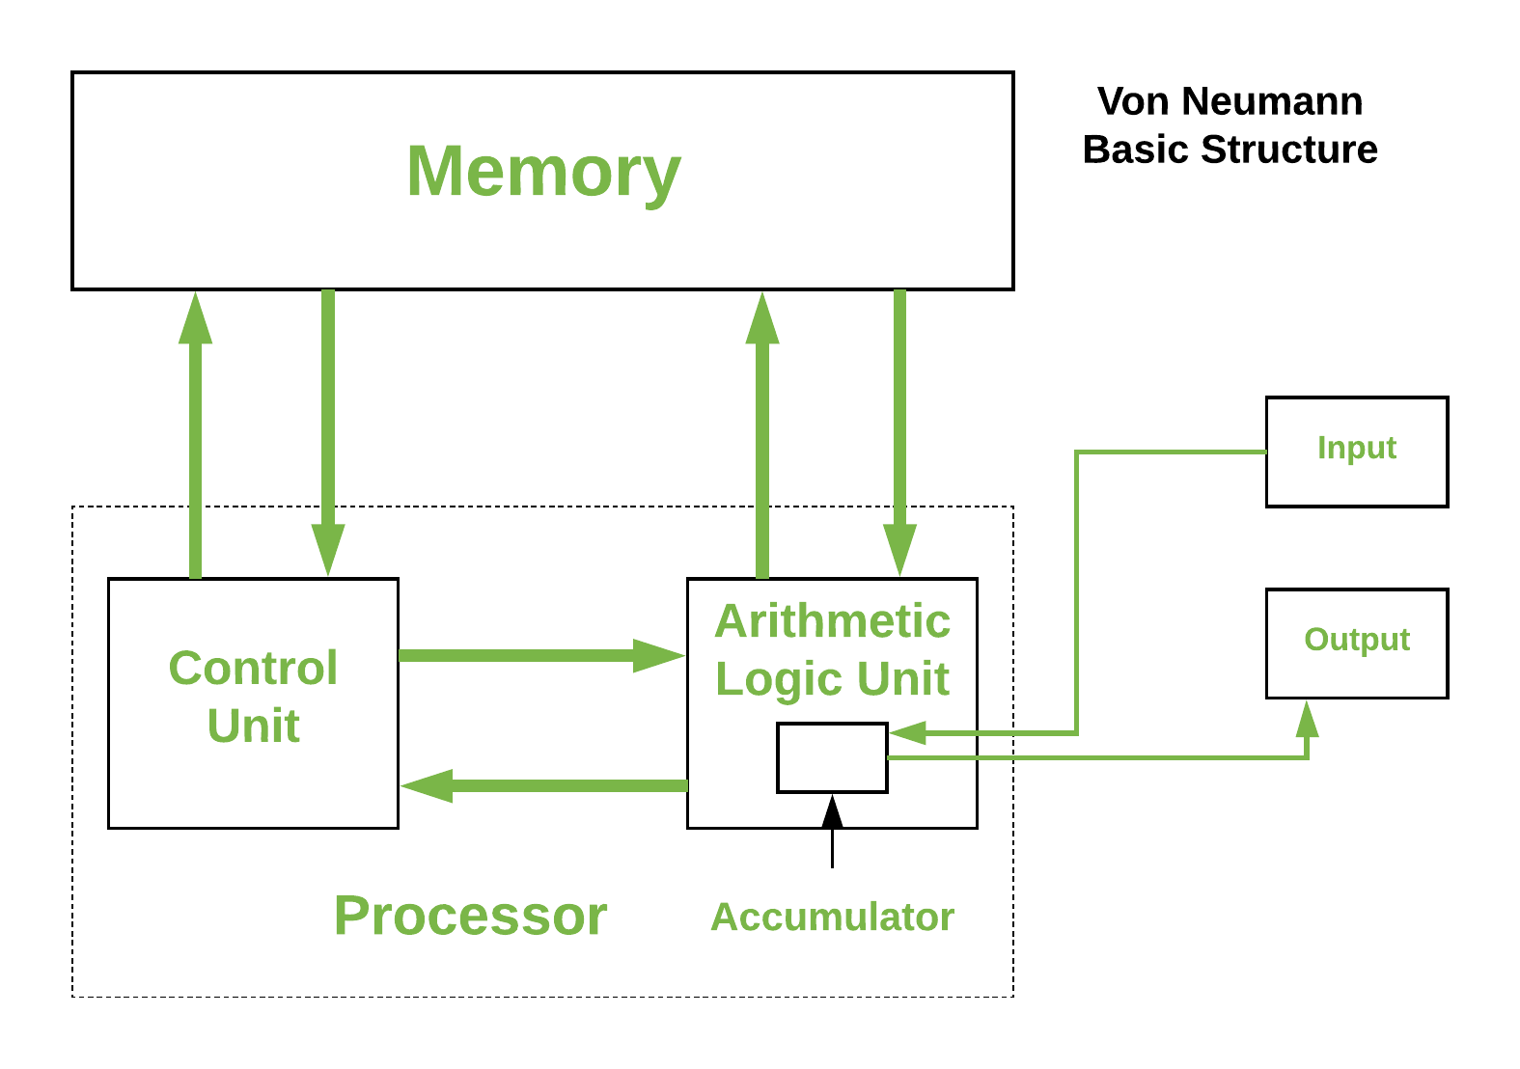
It is also known as ISA (Instruction set architecture) computer and is having three basic units:
- The Central Processing Unit (CPU)
- The Main Memory Unit
- The Input/Output Device.
Von Neumann bottleneck –
Whatever we do to enhance performance, we cannot get away from the fact that instructions can only be done one at a time and can only be carried out sequentially. Both factors hold back the competence of the CPU. This is commonly referred to as the ‘Von Neumann bottleneck’. We can provide a Von Neumann processor with more cache, more RAM, or faster components but if original gains are to be made in CPU performance, then an influential inspection needs to take place of CPU configuration.

Harvard Architecture
In a normal computer that follows von Neumann architecture, instructions, and data both are stored in the same memory. So same buses are used to fetch instructions and data. This means the CPU cannot do both things together (read the instruction and read/write data). Harvard Architecture is the computer architecture that contains separate storage and separate buses (signal path) for instruction and data. It was basically developed to overcome the bottleneck of Von Neumann’s Architecture. The main advantage of having separate buses for instruction and data is that the CPU can access instructions and read/write data at the same time.

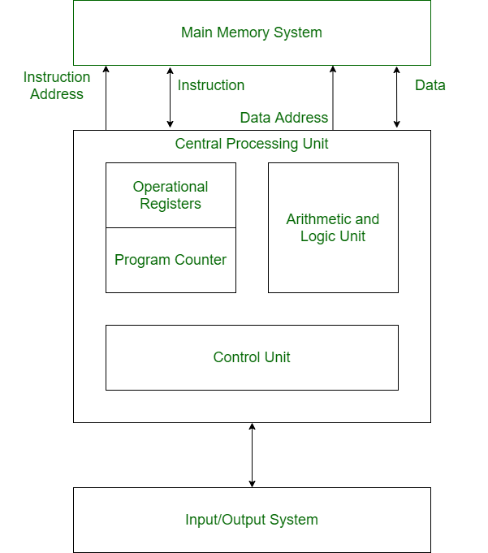
Structure of Harvard Architecture
Advantage of Harvard Architecture:
Harvard architecture has two separate buses for instruction and data. Hence, the CPU can access instructions and read/write data at the same time. This is the major advantage of Harvard architecture.
- Fast and efficient data access: Since Harvard architecture has separate memory spaces for instructions and data, it allows for parallel and simultaneous access to both memory spaces, which leads to faster and more efficient data access.
- Better performance: The use of fixed instruction length, parallel processing, and optimized memory usage in Harvard architecture can lead to improved performance and faster execution of instructions.
- Suitable for real-time applications: Harvard architecture is commonly used in embedded systems and other real-time applications where speed and efficiency are critical.
- Security: The separation of instruction and data memory spaces can also provide a degree of security against certain types of attacks, such as buffer overflow attacks.
Disadvantages of Harvard Architecture:
- Complexity: The use of separate memory spaces for instructions and data in Harvard architecture adds to the complexity of the processor design and can increase the cost of manufacturing.
- Limited flexibility: Harvard architecture has limited flexibility in terms of modifying instructions at runtime because instructions and data are stored in separate memory spaces. This can make certain types of programming more difficult or impossible to implement.
- Higher memory requirements: Harvard architecture requires more memory than Von Neumann architecture, which can lead to higher costs and power consumption.
- Code size limitations: Fixed instruction length in Harvard architecture can limit the size of code that can be executed, making it unsuitable for some applications with larger code bases.
Differences between Von Neumann Architecture and Harvard Architecture
VON NEUMANN ARCHITECTURE | HARVARD ARCHITECTURE
It is ancient computer architecture based on stored program computer concept. | It is modern computer architecture based on Harvard Mark I relay based model.
Same physical memory address is used for instructions and data. | Separate physical memory address is used for instructions and data.
There is common bus for data and instruction transfer. | Separate buses are used for transferring data and instruction.
Two clock cycles are required to execute single instruction. | An instruction is executed in a single cycle.
It is cheaper in cost. | It is costly than Von Neumann Architecture.
CPU cannot access instructions and read/write at the same time. | CPU can access instructions and read/write at the same time.
It is used in personal computers and small computers. | It is used in micro controllers and signal processing.

